
Safeguarding Information


Our Designated Safeguarding Lead is:
Name: Rachel Marshall
Contact: 07779 642680

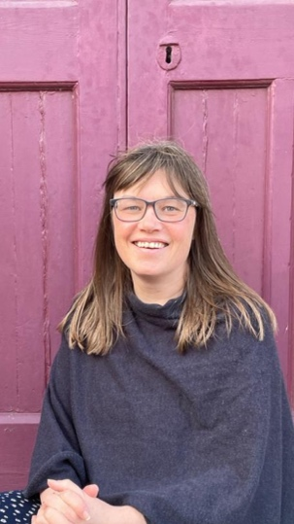
Our Deputy Designated Safeguarding Lead is:
Name: Hannah Allen
Contact: 07866 808300

In an emergency call the local authority
Children’s Services Family Front Door: 01905 822666
Adult Social Care: 01905 768053
or call 999 for the Police

Christian Safeguarding Services’ Advice Line:
07960 751778
available 7 days a week between 7am and 10pm
Website: www.thecss.co.uk

